1) A Liver image shows a point-bearing Foot Yin route with an external course from the foot toward the trunk. Which system is represented?
A) Liver Primary Channel +++++
B) Liver Divergent Channel
C) Liver Luo-Connecting Channel
D) Liver Sinew Channel
Feedback: A point-bearing Foot Yin reference route from the foot toward the trunk identifies the Liver Primary Channel. Why are the other options incorrect? Liver Divergent Channel — The Liver Divergent route is identified by deep separation and convergence with the Gall Bladder pathway. Liver Luo-Connecting Channel — The Liver Luo route begins at LIV-5 and has a characteristic genital continuation. Liver Sinew Channel — The Liver Sinew route is a broad superficial musculotendinous chain with binding regions.
2) A Liver image emphasizes deep entry and joining the paired Gall Bladder Divergent pathway. Which system is represented?
A) Liver Primary Channel
B) Liver Divergent Channel +++++
C) Liver Luo-Connecting Channel
D) Liver Sinew Channel
Feedback: Deep entry and convergence with the paired Gall Bladder pathway identify the Liver Divergent Channel. Why are the other options incorrect? Liver Primary Channel — The Primary route is the ordinary point-bearing Foot Yin reference pathway. Liver Luo-Connecting Channel — The Luo route begins at LIV-5 and is organized as a connecting branch. Liver Sinew Channel — The Sinew route remains superficial and binds through muscles and tendons.
3) A Liver image begins at LIV-5 and continues toward the genital region. Which system is represented?
A) Liver Primary Channel
B) Liver Divergent Channel
C) Liver Luo-Connecting Channel +++++
D) Liver Sinew Channel
Feedback: Origin at the named Luo point LIV-5 with a characteristic genital continuation identifies the Liver Luo-Connecting Channel. Why are the other options incorrect? Liver Primary Channel — The Primary route is not defined as a branch beginning at LIV-5. Liver Divergent Channel — The Divergent route is identified by deep paired-channel convergence rather than a Luo-point origin. Liver Sinew Channel — The Sinew route begins distally and spreads through superficial binding regions.
4) A Bladder image forms a broad superficial posterior chain with multiple joint bindings. Which system is represented?
A) Bladder Primary Channel
B) Bladder Divergent Channel
C) Bladder Luo-Connecting Channel
D) Bladder Sinew Channel +++++
Feedback: A broad superficial posterior musculotendinous chain with multiple bindings identifies the Bladder Sinew Channel. Why are the other options incorrect? Bladder Primary Channel — The Primary route is a narrower point-bearing posterior reference pathway. Bladder Divergent Channel — The Divergent route separates near the posterior knee and enters deeply in relation to Kidney and Bladder. Bladder Luo-Connecting Channel — The Luo route begins at BL-58 and connects with the Kidney Channel.
5) A Bladder pathway begins at BL-58 and connects with the Kidney Channel. Which system is represented?
A) Bladder Primary Channel
B) Bladder Luo-Connecting Channel +++++
C) Bladder Divergent Channel
D) Bladder Sinew Channel
Feedback: BL-58 is the Luo point of origin for the Bladder Luo-Connecting Channel and its paired Kidney connection. Why are the other options incorrect? Bladder Primary Channel — The Primary route does not begin at BL-58. Bladder Divergent Channel — The Divergent route is a deep separation-and-convergence pathway rather than a Luo-point branch. Bladder Sinew Channel — The Sinew route is a broad superficial posterior chain.
6) A Heart image begins at HT-5 and has branches related to the tongue root and eye. Which system is represented?
A) Heart Luo-Connecting Channel +++++
B) Heart Primary Channel
C) Heart Divergent Channel
D) Heart Sinew Channel
Feedback: HT-5 origin with tongue-root and eye relationships identifies the Heart Luo-Connecting Channel. Why are the other options incorrect? Heart Primary Channel — The Heart Primary route is the ordinary posterior Hand Yin point-bearing pathway. Heart Divergent Channel — The Heart Divergent route is organized by deep entry and paired Small Intestine convergence. Heart Sinew Channel — The Heart Sinew route is superficial and musculotendinous.
7) A Large Intestine image begins at the index finger and follows an anterior Hand Yang course toward the face. Which system is represented?
A) Large Intestine Primary Channel +++++
B) Large Intestine Divergent Channel
C) Large Intestine Luo-Connecting Channel
D) Large Intestine Sinew Channel
Feedback: The index-finger origin and ordered anterior Hand Yang course toward the face identify the Large Intestine Primary Channel. Why are the other options incorrect? Large Intestine Divergent Channel — The Divergent route is recognized by deep thoracic Lung relationship and neck convergence. Large Intestine Luo-Connecting Channel — The Luo route begins at LI-6 and continues toward jaw, teeth and ear. Large Intestine Sinew Channel — The Sinew route is broader and marked by muscular and joint bindings.
8) A Large Intestine image shows a branch from LI-6 toward the jaw, teeth and ear. Which system is represented?
A) Large Intestine Primary Channel
B) Large Intestine Divergent Channel
C) Large Intestine Luo-Connecting Channel +++++
D) Large Intestine Sinew Channel
Feedback: LI-6 origin and continuation to jaw, teeth and ear identify the Large Intestine Luo-Connecting Channel. Why are the other options incorrect? Large Intestine Primary Channel — The Primary route begins at the index finger rather than LI-6. Large Intestine Divergent Channel — The Divergent route enters deeply toward the paired Lung relationship. Large Intestine Sinew Channel — The Sinew route is a broad superficial binding pathway.
9) What is the channel shown in the image?
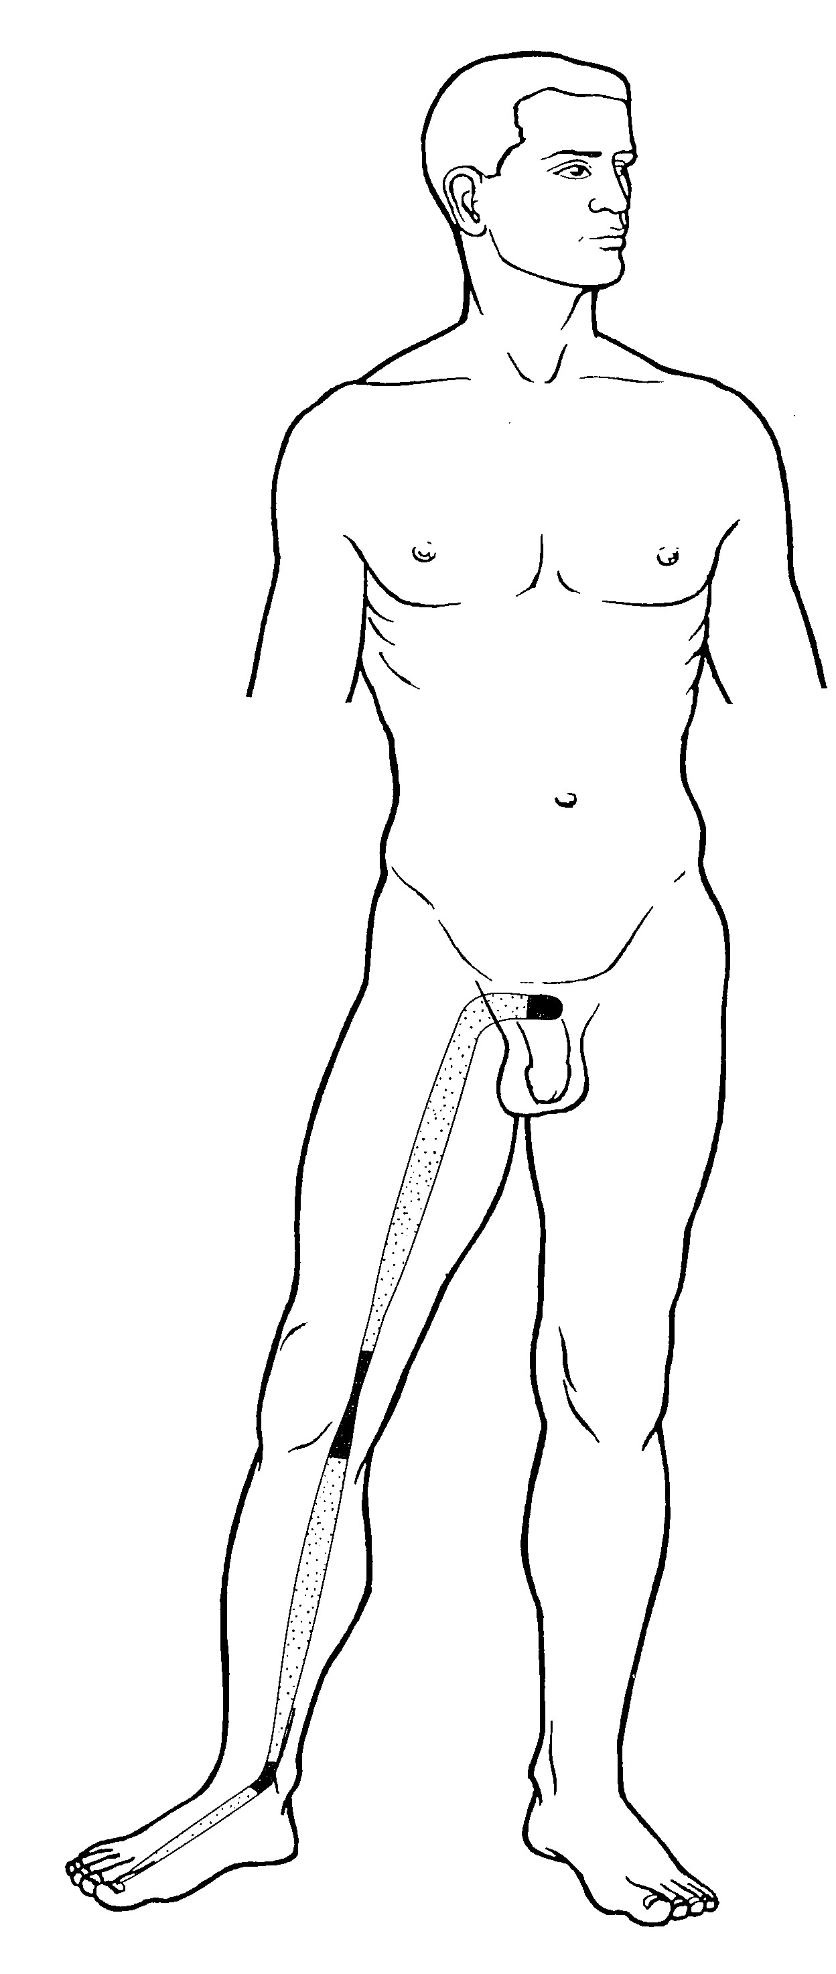
A) Liver Primary Channel
B) Liver Divergent Channel
C) Liver Luo-Connecting Channel
D) Liver Sinew Channel +++++
Feedback: The Liver Sinew Channel begins at the great toe, ascends the medial foot and leg, binds at the medial ankle and knee and continues along the medial thigh to the genital region. Its superficial musculotendinous course and binding regions distinguish it from internal Liver pathways. Why are the other options incorrect? Liver Primary Channel — The Primary Channel is the ordinary point-bearing Foot Yin route. Liver Divergent Channel — The Divergent Channel enters deeply and joins the paired Gall Bladder pathway. Liver Luo-Connecting Channel — The Luo-Connecting Channel begins at LIV-5 and has a characteristic connecting course.
10) What is the channel shown in the image?
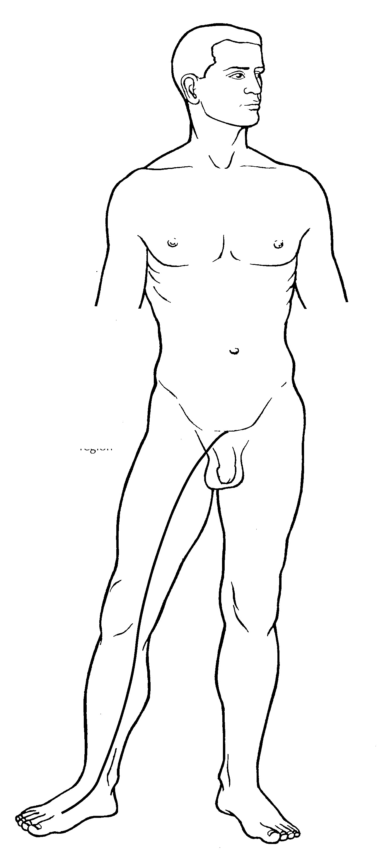
A) Liver Primary Channel
B) Liver Divergent Channel +++++
C) Liver Luo-Connecting Channel
D) Liver Sinew Channel
Feedback: The Liver Divergent Channel ascends from the foot and medial leg toward the pubic and genital region, then follows a deep course that converges with the paired Gall Bladder Divergent pathway. Why are the other options incorrect? Liver Primary Channel — The Primary Channel is the external point-bearing reference route. Liver Luo-Connecting Channel — The Luo-Connecting Channel begins at LIV-5 rather than following this deep convergence pattern. Liver Sinew Channel — The Sinew Channel remains superficial and binds through muscles and tendons.

